承 认 书

SPECIFCATION
确认后请回传PLEASE RETURN BY ONE COPY
兴 和 电 子  XING HE ELECTRON | 客 户 资 料  CUSTOMER’S INFORMATION
产品名称：LED数码屏  PRODUCTION NAME: | 客户:  CUSTOMER:
产品型号: XH-2381AR  PRODCTION TYPE: | 机型:  MODEL NO:
规格摘要:红色、灌胶封装、环保  TYPE: | 料号:  PART NO:
深圳市兴和伟业 SHENZHEN XING HE ELECTRON WORKS
日期:2020-12-18  DATE: | 承办人:  ISSUEDER:
客户确认 APPROVED BY
签名: 日期:
SIGN: DATE:
结论 RESULT：
可向您提供各种规格型号，数码显示屏(数码管)、点阵、背光源
并向您提供全面的优质服务
产品说明书
- 型号（PART NO.）: XH-2381AR
- 说明（Description）：
发光颜色（Emitted Color）：红色
外观颜色（Lens Color）：黑、白两色
外形尺寸（Max Size）：如结构尺寸图所示
极限参数（Absolute Maximum Ratings） 建议使用驱动检测
红色（Red）
参数（Parameter） | 单位（Symbol） | 极限值  （Maximum Rating） | 单位（Unit）
功耗 （Power Dissipation） | Pd | 42 | mW
脉冲电流（Peak Forward Current） | Ifp | 100 | mA
直流电流（Continuous Forward Current） Forward )Current | Ifm | 20 | mA
反向电压（Reverse Voltage） | VR | 5 | V
工作温度（Operating Temperature Range） | Topr | -40 → +80 | ℃
储藏温度（Storage Temperature Range） | Tstg | -40→ +85 | ℃
静电电压（Static Voltage） | Var | 1000 | V
*焊接温度（Lead Sodering Temperature）：260℃ for 3 seconds
*当工作温度高于25℃时，Ifm,Ifp和Id必须降低；电流降低率是-0.36mA/℃（直流驱动），或-0.86mA/℃
（脉冲驱动）功耗降低率是-0.75mW/℃。产品的工作电流不能大于对应工作温度条件Ifm或Ifp的60%。
For operation above 25℃, The Ifm Ifp & Pd must be derated, the Curent derating is –0.36mA/℃ for DC
drive and -0.86mA/℃ for Pulse drive, the power dissipation is -0.75mW/℃. The product working current
must not more than the 60% of the Ifm or Ifp according to the working temperature.
光电特性（Optical-Electrical Characteristic） 建议使用驱动检测
红色（Red）
参数（Parameter） | 测试条件  （Test CONDITING） | 单位（Symbol） | Min | Type | Max | 单位（Unit）
发光强度 （Luminous Intensity） | IF=10mA | Iv | 30 |  | 50 | Mcd
正向电压 （Forward Voltage） | IF=10mA | VF | 1.8 | - | 2.4 | V
反向电流 （REVERSE Current） | VR = 5V | IR | - | - | 50 | uA
波长 （Peak Wavelength） | IF=10mA | λp | 625 |  | 630 | nm
带宽 （Spectral Bandwidth） | IF=10mA | △λ | - | 5 | - | nm
查看角度 （View Angle） | IF=10mA | 2θ1/2 | - | 60 | - | Deg.
3.结构尺寸（Mechanical Outline）:
(未注尺寸公差 Unspecified Tolerances is: ±0.2 发光颜色：红色(RED)
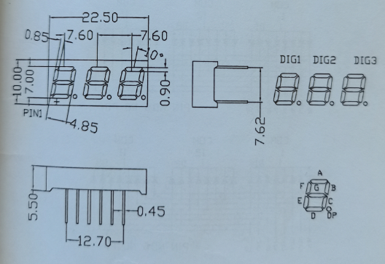
4.电路图（Circuit Diagram）:
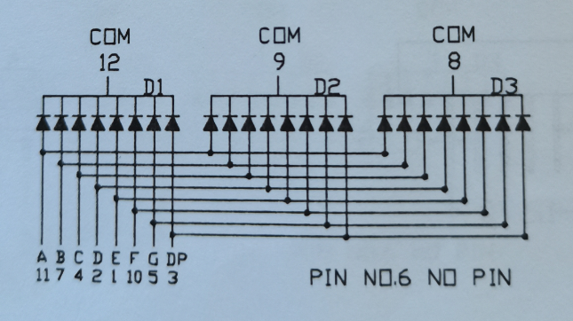
5.保存和焊接条件（Storage & Soldering Condions）:
- Store with care. Storing the units in bad condition ● 注意保存，保存条件不好时，会降低膜片
will cause the reflector sheet and decrease it’s 与反射壳（导光板）的粘附力。
adhesive power. Storage the products under the 推荐保存条件为：温度25℃±10℃
condition :temperature ( 25℃ ± 10℃ ) and humidity 湿度65℃CRH±20℃CRH
(65℃ CRH±20℃ CRH) our recommendation.
- The Soldering Temperature is 260±5℃ and Soldering ● 焊接温度260℃±5℃，焊接时间小于3秒，
Time should be less than 3 sec, and soldering iron 烙铁功率小于30W。
power should be less than 30W.
- The soldering point should be farther than 1.6mm ● 焊接点应离产品实体大于1.6mm。
from boby. 6．外观判定条件(Surface check condition)
外观目测条件：40W日光灯作光源与产品相距约1米（环境亮度）200 Lux）检测者与产品视距为25-30cm。
Visual check condition: Use a 40W lamp as light (Ambient luminance about 200Lux), the distance between lamp and product about one meter, between checker and product about 25-30cm for check.
标准：黑.白点大小为0.1≤￠＜0.15最多允许有3个，且间距必须大于1cm,
Standard: the size of black dot and white dot is 0.1≤￠＜0.15 and the quantity of the dot for three are accepted, and the distance must be more than 1cm,
黑.白点大小为0.15≤￠＜0.20最多允许有2个，且间距必须大于1cm，
the size of black dot and white dot is 0.15≤￠＜0.20 and the quantity of the dot for two are accepted, and the distance must be more than 1cm,
黑.白点大小为0.20≤￠＜0.25最多允许有一个，划伤￠≤0.1mm,长度＜1mm,最多允许1条；面花，膜纸花，当产品不反光，且发光效果不见该缺陷时，则可接受。
Below the condition are accepted:
The size of black dot and white dot is 0.20≤￠＜0.25 and the quantity of the dot for one is accepted.
The scar is ￠≤0.1mm and the length less than 1mm, the quantity of this scar for one is accepted.
Surface scar, if that cannot found when the product was luminous so that is accepted.
7．发光效果检验条件：在环境亮度＜9Lux的条件下目测，视距应在25-30cm 。
Luminescence check condition: Visual check under ambient luminance is less than 9Lux and distance at 25-30cm

标准：黑.白点大小为0.1≤￠＜0.15最多允许有3个，且间距必须大于1cm,
Standard: the size of black dot and white dot is 0.1≤￠＜0.15 and the quantity of the dot for three are accepted, and the distance must be more than 1cm,
黑.白点大小为0.15≤￠＜0.20最多允许有2个，且间距必须大于1cm，
the size of black dot and white dot is 0.15≤￠＜0.20 and the quantity of the dot for two are accepted, and the distance must be more than 1cm,
黑.白点大小为0.20≤￠＜0.25最多允许有一个，划伤￠≤0.1mm,长度＜1mm,最多允许1条；面花，膜纸花，当产品不反光，且发光效果不见该缺陷时，则可接受。
Below the condition are accepted:
The size of black dot and white dot is 0.20≤￠＜0.25 and the quantity of the dot for one is accepted.
The scar is ￠≤0.1mm and the length less than 1mm, the quantity of this scar for one is accepted.
Surface scar, if that cannot found when the product was luminous so that is accepted.
尺寸检测条件：依据图纸，使用计量卡尺，注意检测人为误差。
Size check condition: Use the measure ruler based on the product drawing for check, and need note that the tolerance make by operator.
电性能检测条件：依据图纸，工艺，在额定工作电压或恒定的电流下，执行《QA成品检验方法》功能的相关内容，带针脚产品须作5PCS上锡实验。
Electrical check condition: use the rated voltage or constant current for the product based on the product drawing and IE document and performance the《QA成品检验方法》for check,

8．《QA成品检验方法》：
 | 判定范围  ITEM | MAJOR | MINOR
Final product check standard  成  品  检  验  判  定  标  准 | 外  观  检  验  Surface check condition | - 膜纸：不齐、贴歪≥0.25mm。  Membrane:  not uniform or deflective that must be less than 0.25mm,  - 引脚氧化或掉铜皮、或不按要求上锡披峰。  The pins are oxygenation or lose copper or cannot meet the SPEC of soldering reliability.  - 条形歪斜、松脱、脚短/长、膜纸变形、翘起。  Bar deflective, loss, pins short/longer,  membrane distortion, tilt.  - 产品弯曲、变形、划伤、毛刺。  Product inflect, scar, burr, | - 膜纸不齐导致露出或超宽0.25mm内进0.25mm以下，0.15mm以上；脏、皱等。  Make for bare or exceed width between 0.25mm and 0.15mm caused by membrane were not uniform; dirty, ruck etc.  - 产品反面非有效发光区域有手印、水渍印。  Has the fingerprint or watermark on the background of the product there are not the area of luminous.
Final product check standard  成  品  检  验  判  定  标  准 | 尺 寸  检 验  Size check condition | - 长、宽、厚等重要尺寸超差≥0.2mm,其它尺寸超差在0.25mm以上。  The tolerance of Length, width and thick must ≥0.2mm and other tolerance more than 0.25mm.  - 膜纸过大在0.25mm以上。  Membrane over than 0.25mm | - 虚边、毛刺等引起的尺寸超差在0.2mm以下,0.1mm以上。  The size tolerance of product that caused by burr edge shall between 0.1-0.2mm.  - 小于严重缺陷的尺寸超差。  Less than the important tolerance .
Final product check standard  成  品  检  验  判  定  标  准 | 功 能  发 光  效 果  检 查  Functional check condition | - 管芯发光颜色不符合图纸要求。  The color of luminous is differenced for the SPEC.  - 闪亮、颜色/色差、暗光、暗带与样板相差较大。  Flash, color, dark light that more difference than the golden sample.  - 膜纸漏光直径≥0.25。  For the membrane the diameter of light Leakage≥0.25. | - 轻微色差、暗光、暗带、暗斑。  Minor of the chromatism, dark light, dark spot.  - 两端部发光不均匀。.  The luminescence is asymmetry at the two ends.

